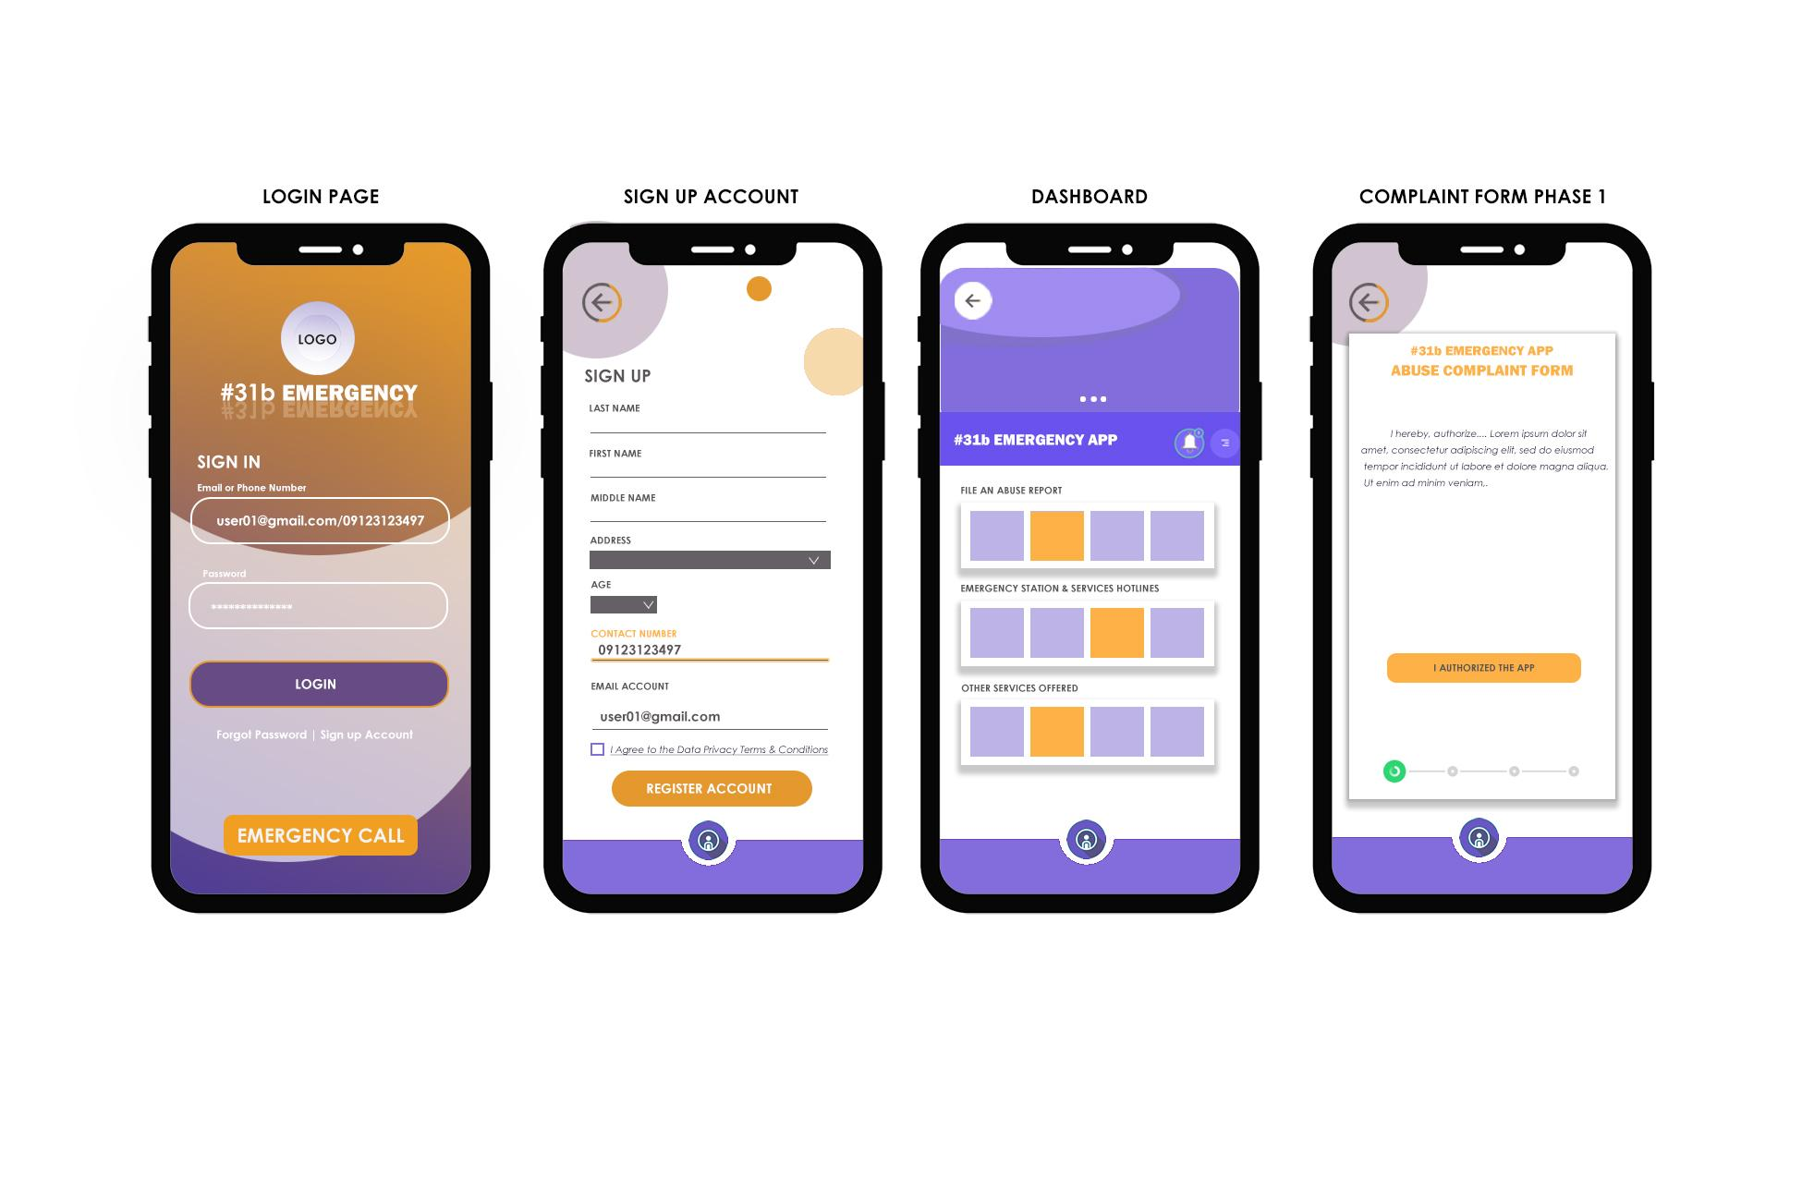

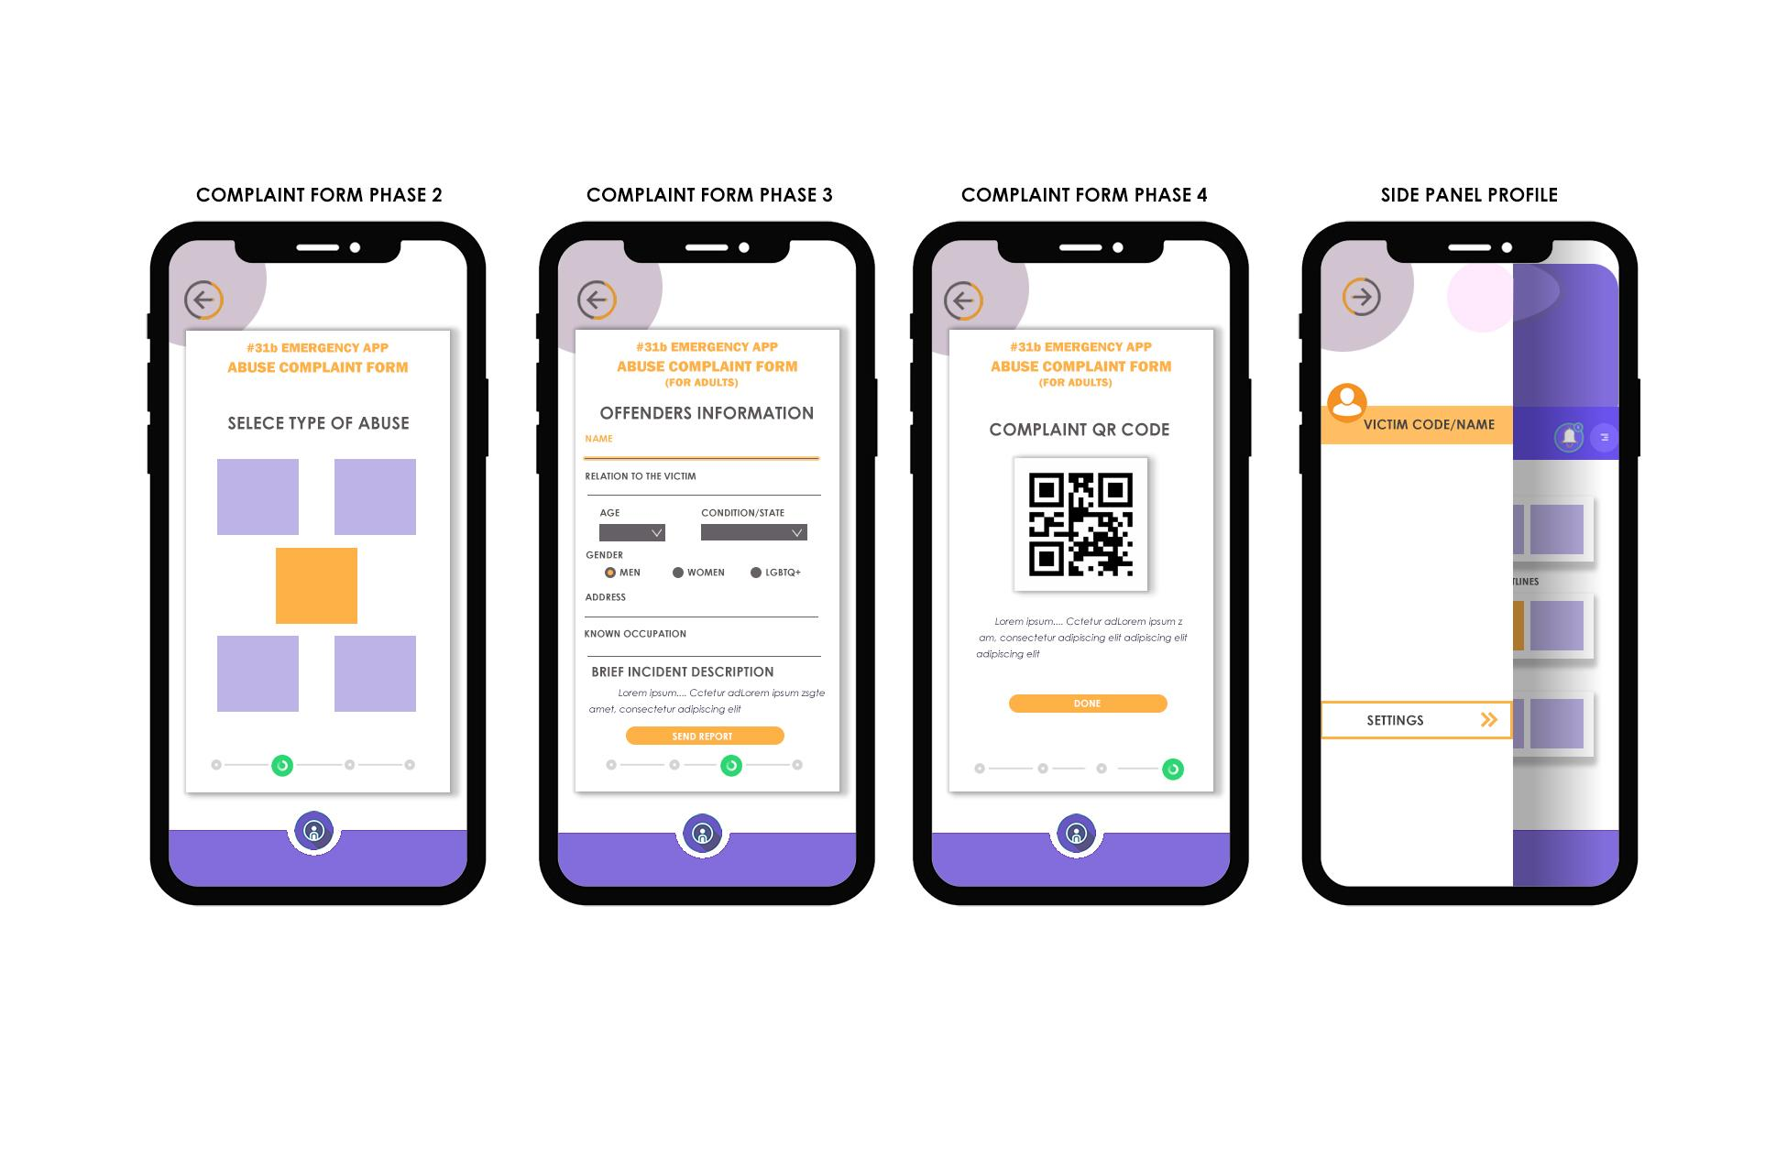

**\*\*\*REQUEST PERMISSION (textbox that will pop up when the app is installed)**

“To continue using this application, #31b Emergency Mobile App needs access to: ”

-Device’s Location

-Storage

-Camera

-Contacts

**Dashboard texts**

Abuse has NO EXCUSE  
Stop VIOLENCE and ABUSE

**Authorize application**

I, understand and agree that by providing my personal data or by clicking the applicable icon or button, I am agreeing to the Privacy Notice and giving my full consent to #31B Application and its affiliates as well as its partners and service providers, if any, to collect, store, access and/or process any personal data I may provide herein, such as but not limited to my name and email address, whether manually or electronically, for the period allowed under the applicable law and regulations. I acknowledge that the collection and processing of my personal data is necessary for such purposes. I am aware of my right to be informed, to access, to object, to erasure or blocking, to damages, to file a complaint, to rectify and to data portability, and I understand that there are procedures, conditions and exceptions to be complied with in order to exercise or invoke such rights.

**Type of Abuse**

**-**

**-**

**-**

**-**

**-**

**About**

#31B is a mobile application that enables users to file a complaint report virtually anywhere and anytime. The aim of the mobile application is to provide an easier way of reporting abuse cases to the nearest authorities.

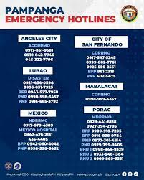

Sta Rita Municipal Police Station

2.0

(1) · Government office

National Road, Santa Rita, 2002

2J56+FH Santa Rita, Pampanga

(045) 434 0605

Lubao Police Station

2.7

(6) · Police department

WHQX+2WW, Lubao, Pampanga

(04597) 15431

Guagua City Police Office

5.0

(2) · Police department

XJ8M+39J, Guagua, Pampanga

(045) 409 4420

Porac Municipal Police Station

No reviews · Government office

National Road, Porac, 2008

4FC3+2M Porac, Pampanga

(045) 329 2166

Sasmuan Municipal Police Station

No reviews · Government office

National Road, Sasmuan, 2004

WJ24+62 Sasmuan, Pampanga

(045) 435 0104

Floridablanca Municipal Police Station

No reviews · Government office

National Highway, Floridablanca, 2006

XF45+WG Floridablanca, Pampanga

(04597) 01291

dswd pampanga  
[(045) 861](https://www.google.com/search?q=dswd+guagua+pampanga&biw=1366&bih=667&tbm=lcl&ei=d0caYaSjHsSUr7wPt9qc8Ak&oq=dswd+guagua+pampanga&gs_l=psy-ab.3..0i512k1.6745.7658.0.8001.3.3.0.0.0.0.258.508.2-2.2.0....0...1c.1.64.psy-ab..1.2.508....0.jQtIQ8rB30o#) 2143

045-860-5629-1031

| FO III | Marites M. Maristela | Regional Director | Tel. No.: (045) 8-961-21-43 Local 108 |
| --- | --- | --- | --- |
| [Website: https://fo3.dswd.gov.ph](http://www.fo3.dswd.gov.ph/) |

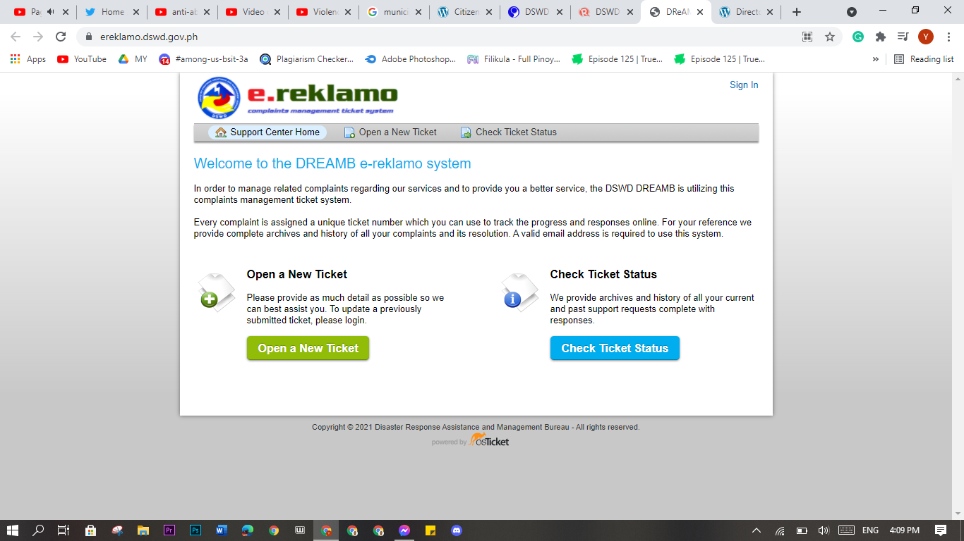

Social Welfare Pampanga

| Institution | Contact Person | Programs and Services | Clients |
| --- | --- | --- | --- |
| CASA MIANI STO. NIÑO St. Jerome Emiliani Road, Sto. Niño, Lubao, Pampanga  Tel. #: (045) 971-6263  e-mail: casamiani@hotmail.com | Rev. Fr. Michael Escoto, crs Director | Educative Environment; Educational Program; Religious Formation from Elementary to Highschool; Social Services Health Care; Sports and Recreation | Male children youths ages 8 to 18 who are abandoned, orphaned, school drop-out and street children |
| MOTHER IGNACIA NATIONAL SOCIAL APOSTOLATE CENTER, INC. - MINSAC Katutubo Village Planas, Porac, 2008 Pampanga Cell #: (0919) 840-5154 | Sr. Ma. Flora Castillo, RVM | education program - ECCD, tuloy-aral (access to technical and material assistance) to out-of-school youth (OSY) and OSY at risk and livelihood assistance to parents micro-finance self-reliance program - extends loan assistance, mobilize savings and facilitates formation of cooperatives | out-of-school youth (OSY) and OSY at risk, parents of OSY, women, families and communities |
| AWECA FOUNDATION, INCORPORATED Unit "S", S & L Bldg., Essel Park, Telabastagan, San Fernando, 2000 Pampanga Tel. #: (045) 888-6715 E-mail Address: info@awecafoundation.org.ph | Ms. Ma. Rollyn F. Palo Executive Director | Dev't. of Literacy and Training Assistance for Indigenous People (DELTA-IP) - basic literacy program and community organizing for the benefit of IPs which includes livelihood, literacy program, provision of trainings, improvement of the community in terms of physical development - Pamaskong Handog sa mga Bata - gift giving to indigent children - Sagip Kalikasan - project for environment awareness (tree planting and clean-up drive - educational assistance project - educational assistance to poor but deserving children from elementary to college. This includes allowance, payment of tuition fees and honing of skills and talents of the children | children and youth, families and communities |
| SOCIAL ACTION CENTER OF PAMPANGA (SACOP) (formerly: Grassroots Organization Volunteers, Inc.) Government Center, Maimpis, San Fernando, 2000 Pampanga Tel. #: (045) 961-3562; 860-5337 to 38 Fax #: (045) 961-4316 Email Add: sacpampanga@yahoo.com URL :www.sacop.org.ph | Fr. Francisco F. Dizon Executive Director | scholarship program, advocacy on national laws, community organizing, faith communities for poor and aetas families, resettlement communities | families and communities |
| FRESH HOPE FOR FAMILIES PHILIPPINES, INC. 2192 New York St., Villa Sol Subd. Brgy. Anonas, Angeles, Pampanga Tel. # (02) 254-1819 CP# 0918-963803/0915-5457663 | Ms. Ruth S. Callanta President | temporary shelter, homelife, social services, educational, psychosocial services, community outreach programs for streetchildren and families | 7-18 years old young women and children, sexually abused, commercially exploited and streetchildren |
| FRESH HOPE REFUGE SHELTER, INC. #13-7 Colorado St., Villa Sol Subd., Anonas, Angeles City, Pampanga | Mrs. Benia Fajemolin Executive Director | temporary shelter, homelife, social services, psychosocial services | abused, orphaned, abandoned and neglected children |
| INTERNATIONAL CHILDREN'S CARE (ICC) PHILIPPINES FOUNDATION, INC. Sitio Bucaran Bodega, Floridablanca, Pampanga CP# 0919-2746829/09264728374 Email: icc_philippines@yahoo.com.au | Mr. Sulficio Mallorca, Jr. Administrator | residential care, social services, homelife, health, education, sociocultural, psychological and spiritual | 3-8 years old orphaned, abandoned and neglected children |
| ROTARY CLUB OF CLARK CENTENNIAL STREET CHILDREN FOUNDATION, INC. DBA ANGELES BAHAY BATA CENTER Barangay Cuayan, Angeles City, Pampanga Tel. # (045) 889-0557 CP #: (0918) 5115227 e-mail add: angelesbahaybata@yahoo.com | Mr. Joey Pineda Project Director | Residential / Home Care, Feeding, Tutoring, Special Program & Activities, Education (Formal and Non-formal Schooling) | 7-16 years old children and youth |
| SEND THE LIGHT MINISTRIES FOR THE FILIPINO CHILDREN FOUNDATION,INC. Block 2 Lot 165, Dapdap, Mabalacat, Pampanga Tel. No. (045) 322-43-06 e-mail address: eclendening @yahoo.com | Mary Elizabeth Clendering Executive Director | Temporary care/shelter, educational assistance | 0-10 years old orphaned and neglected children |
| RAYMOND DENNIS TRINDER MEMORIAL FOUNDATION, INC. 619 corner Jackfruit cor. Pear St. San Francisco, Mabalacat, Pampanga Tel. # (045) 331-3173 | Ms. Adela Timbang President | provide assistance to single parents and rape victims, assist in the living condition of distressed citizens particulary those who are handicapped by reasons of poverty, youth, physical and mental disability, illness, old age '- provide rehabilitation for youth, disabled and released prisoners | youth, women (single parents), OPs, PWDs, family, community and released prisoners |
|  |  |  |  |
|  |  |  |  |

<https://luzon.graceslist.org/directory/categories/domestic-violence>

<https://pcw.gov.ph/>

Philippine Commission on Women

Republic Act 7610: Special Protection of Children Against Abuse, Exploitation and Discrimination Act

AN ACT PROVIDING FOR STRONGER DETERRENCE AND SPECIAL PROTECTION AGAINST CHILD ABUSE, EXPLOITATION AND DISCRIMINATION, PROVIDING PENALTIES FOR ITS VIOLATION AND FOR OTHER PURPOSES.

